CSC8502 Coursework

# Controls:

P – Enables post processing.

O - Disables post processing.

C – Start/restart the camera automated movement.

V – Enable player-controlled movement.

Mouse – Pan camera.

When player control enabled:

W – Moves camera forward.

S – Moves camera backwards.

A – Moves camera left.

D – Moves camera right.

Shift – Moves camera up.

Space – Moves camera down.

# Screenshots:

The screenshot above shows the terrain of the scene which is generated from a heightmap. The heightmap is textured with 3 separate textures and corresponding bump maps. The textures are applied depending on height with sand being towards the bottom, a sparser grass in the middle and a thicker grass at the top. The textures blend to create a seamless transition.

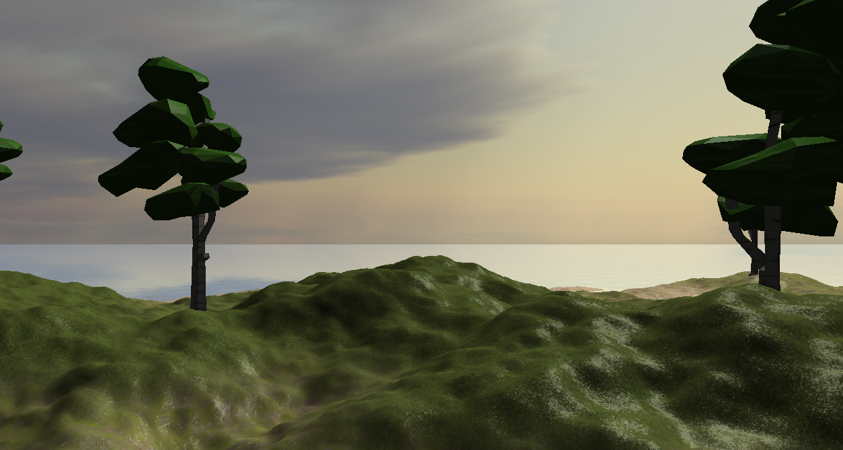It also shows there is a sky box applied to the scene which are the clouds in the distance. There is water in the scene also that is partially transparent so the heightmap can be seen through it. It also reflects the skybox as you can see a reflection of the clouds in the water.

The screenshot above shows the heightmap with the bump map applied more clearly. The light is coming from the direction of the sun which is from the right side of the image. The lighting shows the ambient, specular and diffuse working correctly on the texture and the bump map is correctly applied. The screenshot also shows some tree models that are on the terrain and react correctly to the light as the side facing away from the sun is darker than the side facing it.

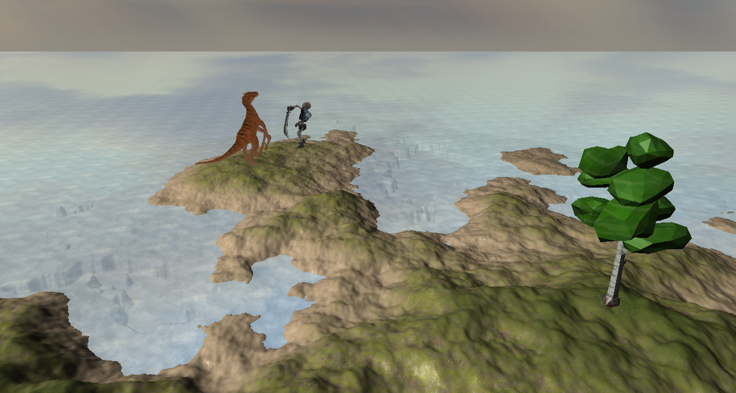

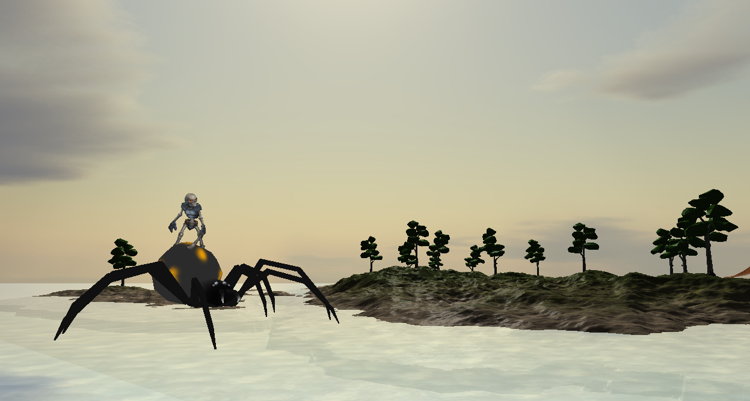This screenshot shows a fierce battle between a velociraptor and a skeleton which are attacking each other with full skeleton animation on each model.

A skeleton rides a water walking spider which shows the scene graph is being correctly applied to the scene as only the spider has been programmed to move yet the skeleton still rides on top.

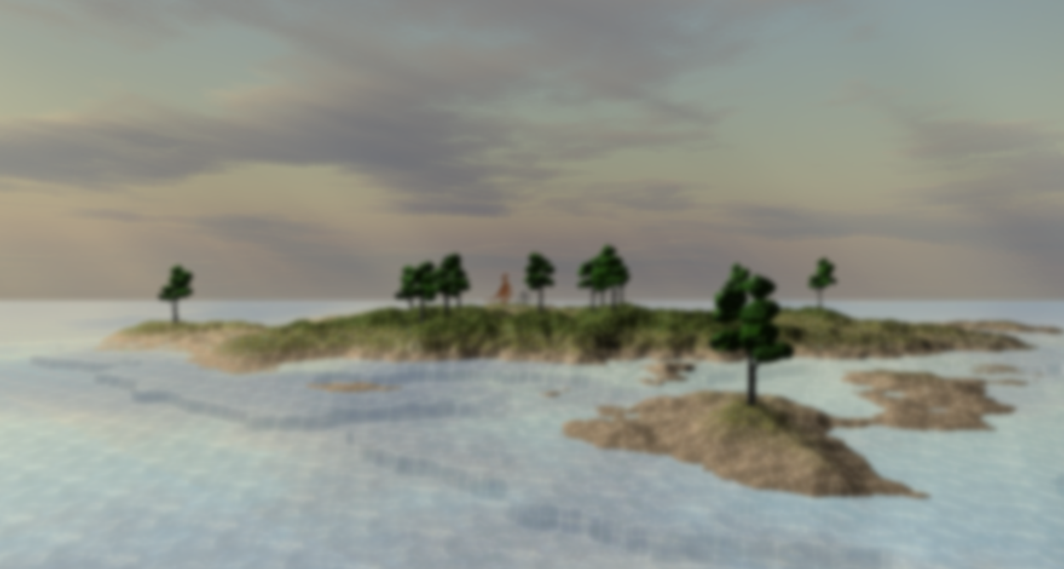

Post processing is applied over the top to create a blur effect of the scene.

YouTube link:

https://youtu.be/my6Q8gR9VpU